Name: Sally Phan
Year: 10

Splatter – Model sitting
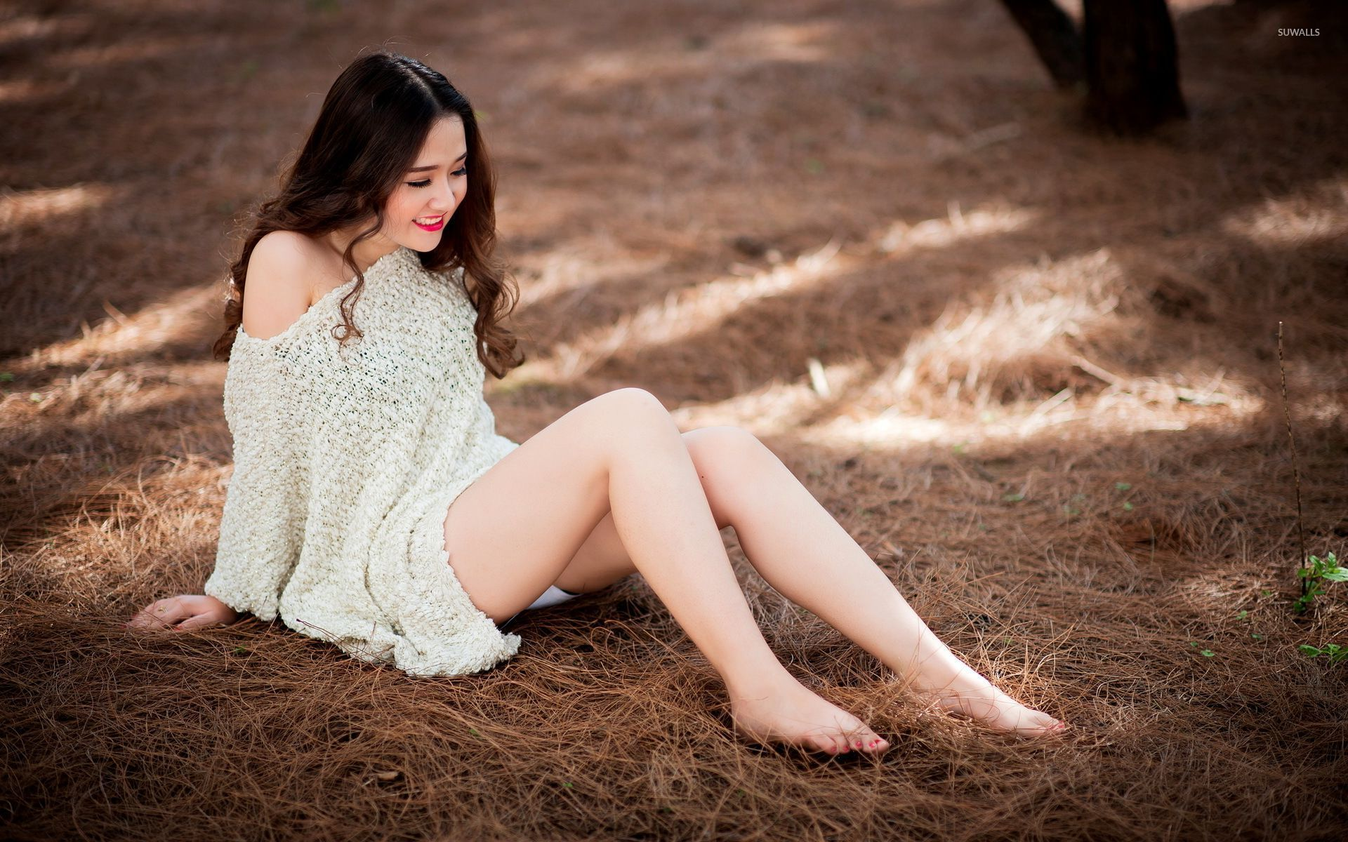

Step 1:

- Open the model sitting on Photoshop and Crtl + J to make the new layer 1 and then hide it.
- Click Polygonal Lasso Tool then select around the model. Make sure I was select the mother layer and delete it.

Step 2:

- Put hide away for the second layer. Select the Quick Selection Tool and select around her then Ctrl + J to make the new layer and also delete the Layer 1.
- Copy the Layer 2 to makes another layer. Click the Layer 2 and go to Filter select the Liquify then click to the first tool on the right hand and put her back going out then click ok.

Step 3:

- Select the layer mask for the Layer 2 and Layer 2 copy.
- Click on Layer 2 and Ctrl + I to fill black for that layer. After that click on the Layer 2 copy and select the Brush Tool then click on the Brush number 51, make the brush bigger, makesure the colour is black and lick on her back and hand.
- Click on the Layer 2 select the Brush number 99 and make the colour is white then fill around the back and hand I put out before. Used the bigger size and smaller size depend on how it looks good.

Step 4:

- Click on Solid colour and select the dark blue colour then make it become the Exclusion, fill the Opacity down about 80%.

Step 5:

- Save it in JPG.

Here we go:



